## Chapter 1

**INTRODUCTION**

In the mobile device market there is a large number of applications to help people monitor intake or provide suggestions to lose weight and manage a healthy diet. However, the vast majority of these apps consume a lot of time by having to introduce food one by one. This application presents the work to develop and pilot test a new Android application, FoodRecipe, aimed at people around all ages, specially those from rural environments or with limited technical knowledge, to manage their food from the items that appear on their grocery receipts, avoiding the obligation to introduce one by one those foods, and generating recommendations. To achieve this final objective, specific objectives have been completed as indicated in the methods section. The app is easy to download and install.

Food Recipe App is a cooking app. The app provides great step-by-step instructions, guides, tips and tricks on how to cook delicious meals. The app allows users to add favorite recipes and it’s easy to share your favorite recipes with family and friends.

The app provides you to add your own recipe and you can go through that whenever you want. The app allows users to add picture of the recipe and step-by-step instructions. Here user can update the picture of the recipe whenever he/she want. The app allows user to delete the recipe if he/she is not interested in it. It is like recipe book, you can write your own recipe method and store it in the app.

## Chapter 2

**SYSTEM REQUIREMENTS**

**3.1 SOFTWARE REQUIREMENTS**

Operating System : Microsoft WindowsXP/Vista/7/8/10

Programming Language : HTML, CSS, Javascript, Java and flutter

Drivers : None

Tools : Android Studio, Firebase

## 3.2 HARDWARE REQUIREMENTS

The following are the Hardware Requirements:-

System Hard Disk : 50 GB or more

Processor : Pentium Dual Core or Intel Corei3/i5/i7

Processor Speed : 1.5GHz or higher

Memory : Minimum 1 GBRAM

Any other devices : None

## Chapter 3

**LITERATURE SURVEY**

Technology can help people to maintain a healthy diet . A large number of applications have been designed for this purpose. Some manage sports activities or physical exercise plans. Others focus on food control. Nevertheless, most of those applications unify both aspects: control of food, caloric intake and sports activities.

Generally, applications for food control have the main function of registering and storing meals throughout the day. The user must enter, one by one, the type of food ingested. This controls the calories ingested in a day and the specific nutrients (proteins, carbohydrates, fats, vitamins), and allows comparisons with the data recorded from previous days. Applications can incorporate other functions such as: set goals to lose weight over a period of time; store healthy food recipes; or include a step counter to complement the record of calories ingested with those that have been burned throughout the day doing physical exercises.

Mobile applications have been developed to scan purchase receipts. We found a study to measure the effects of front-of-pack interpretive nutrition labels on grocery shopping using label scanning. In another article, the authors tried to know, by registering receipts, the behavior of buying food in households. In addition, that will be effective if there is a commitment by the user to scan the tickets. However, we have not found any mobile application that photographs and records the groceries receipts to compare them over a period of time, and based on that comparison show recommendations for a balanced diet.

## Chapter 4

**SYSTEM DESIGN**

FoodRecipe Note app has been developed for a minimum Android 6.0 version, equivalent to the API level 23, and the version with which the project has been compiled is Oreo 8.1, equivalent to the API level 27. Support for older APIs is provided since the target users of the application tend to own low-end devices that are not frequently updated and the latest data shows that more than 84 % of Android devices run a version 6.0 or higher. Nevertheless, the proposed application has been tested in new and more powerful devices with similar results.

**Java**: Java is a class-based, object-oriented programming language that is designed to have as few implementation dependencies as possible. It is a general-purpose programming language intended to let application developers write once, run anywhere (WORA), meaning that compiled Java code can run on all platforms that support Java without the need for recompilation. Java is the foundation program for Android applications, so it’s the general choice for [**mobile developers**](https://www.upwork.com/hire/mobile-app-developers/).

**Flutter:** It is an open-source UI software development kit created by Google. It is used to develop applications for Android, iOS, Linux, Mac, Windows, Google Fuchsia, and the web from a single codebase. The first version of Flutter was known as codename "Sky" and ran on the Android operating system.

**Firebase:**Firebase is a platform developed by Google for creating mobile and web applications. In our project we are using firebase as a backend.

## Chapter 5

**SYSTEM IMPLEMENTATION**

FoodRecipe Note App is an android application which helps to manage recipe activities. To implement this application, the person just need a smart phone with an internet connection. He/she can store the step by step methods of making the recipe and can update the note whenever they want and monitor their work from this application and also can manage and maintain recipe data..

### Importing Databases and its functions

Database for this application is created in firebase cloud storage. This project consists of 4 modules, admin, teacher, student and parent.

## Chapter 6

**TESTING**

Testing is an essential footstep in the development of a system. Testing is the course of action of verifying the correctness of the system that is already developed. After the system is developed, it needs to be verified with the functionalities that each functional specification is working in a correct manner. It also ensures the newly developed system meets the quality requirement and genuineness. Testing is performed at various levels of the system with the sole in tension of making a secure and qualified system. In other words, the testing is performed to check whether the system is working as in the same way the system was designed and expected to work. The testing is mainly performed to achieve and affirm the quality of the project. The testing performs the quality assurance for the software. Testing involves writing test cases for each operation to check and verify the functionality of the module.

The application is tested by importing flutter widgets from package: flutter/material.dart where this package is globally available to acquire all its repositories.

import 'package:flutter/material.dart';

import 'package:flutter_test/flutter_test.dart';

void main() {

testWidgets('Counter increments smoke test', (WidgetTester tester) async {

expect(find.text('0'), findsOneWidget); expect(find.text('1'), findsNothing);

await tester.tap(find.byIcon(Icons.add)); await tester.pump();

expect(find.text('0'), findsNothing); expect(find.text('1'), findsOneWidget);

});

}

|  |  |  |  |  |
| --- | --- | --- | --- | --- |
| **Test case name** | **Operation** | Expected result | Actual Result | Pass/Fail |
| login | Checking Recipe | Successful if it is displayed | Successful and recipe list is displayed | Pass |
| Updating New Recipe | If the recipe is present update the details | Successful if the details entered newly | Successfully entered recipe in the note | Pass |
| Accessing Recipe Details | Login as user and accessing the information regarding recipe | Successful if details are accessed | Recipe’s data not found | Fail |

**Await**: It is the expressions makes to write the asynchronous code almost as if it were synchronous. The await expressions evaluate the main function, and then suspends the currently running function until the result is ready–that is, until the Future has completed. The result of the await expression is the completion of the future.

**Chapter 8**

**SCREENSHOTS**

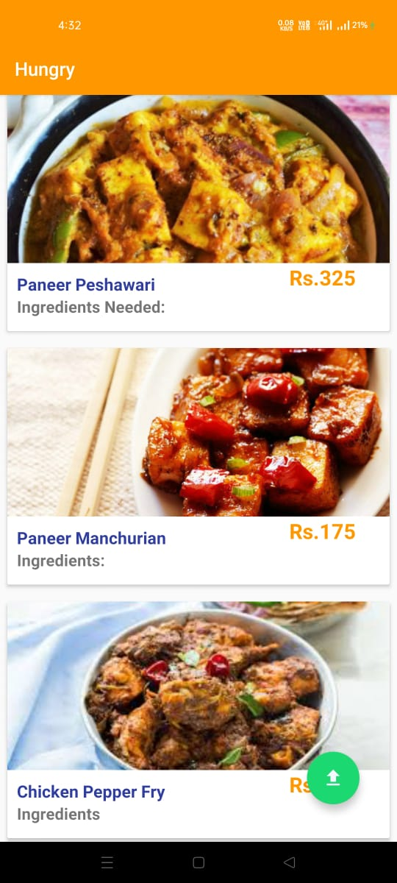

* 1. **Home page of the application**

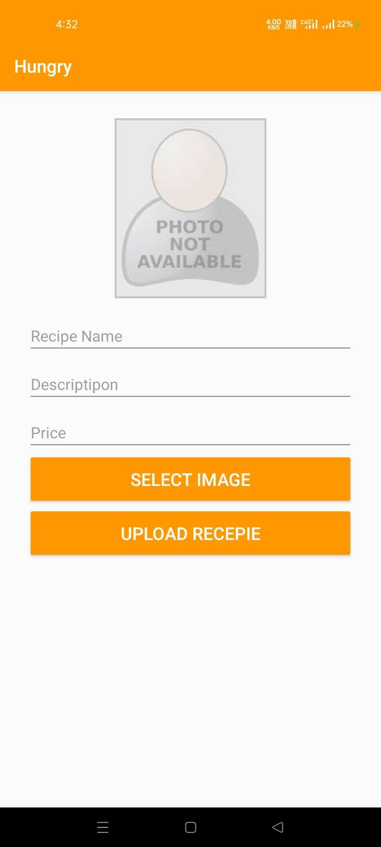

**7.2 Upload recipe**

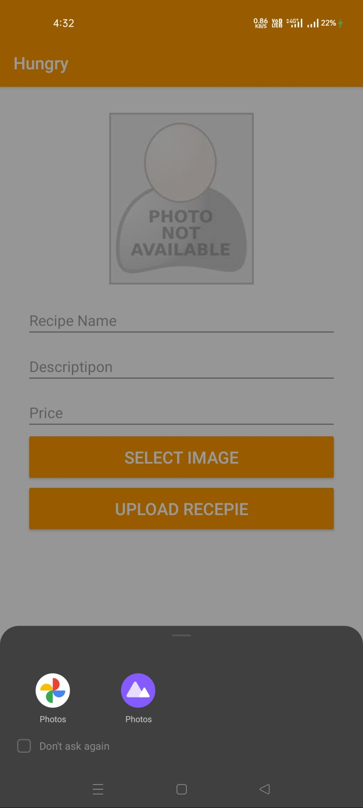

**7.3 Select image of the recipe**

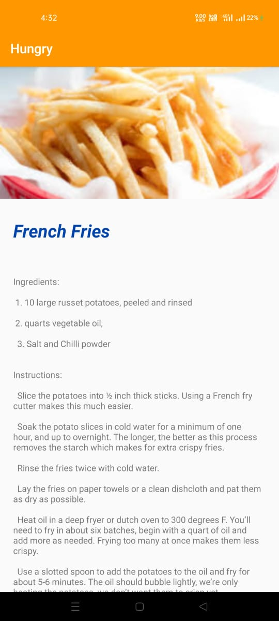

**7.4 Newly Stored Recipe in the application**

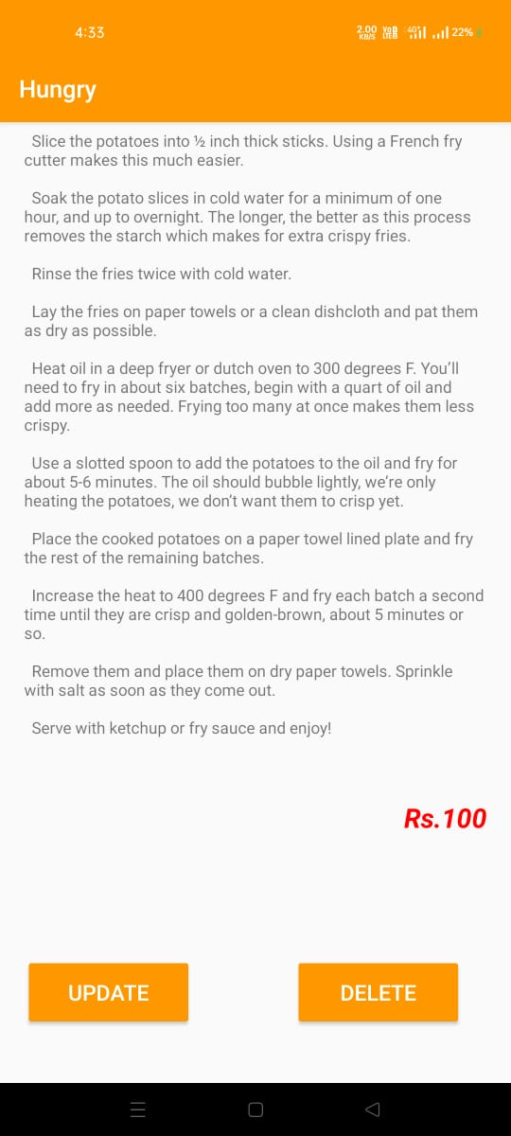

**7.5 Update option for the users**

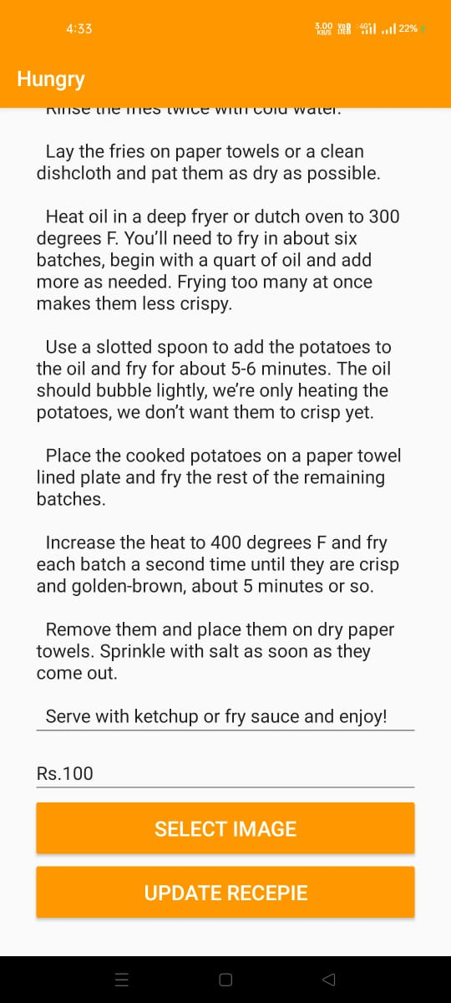

**7.6 Updating existing recipe**

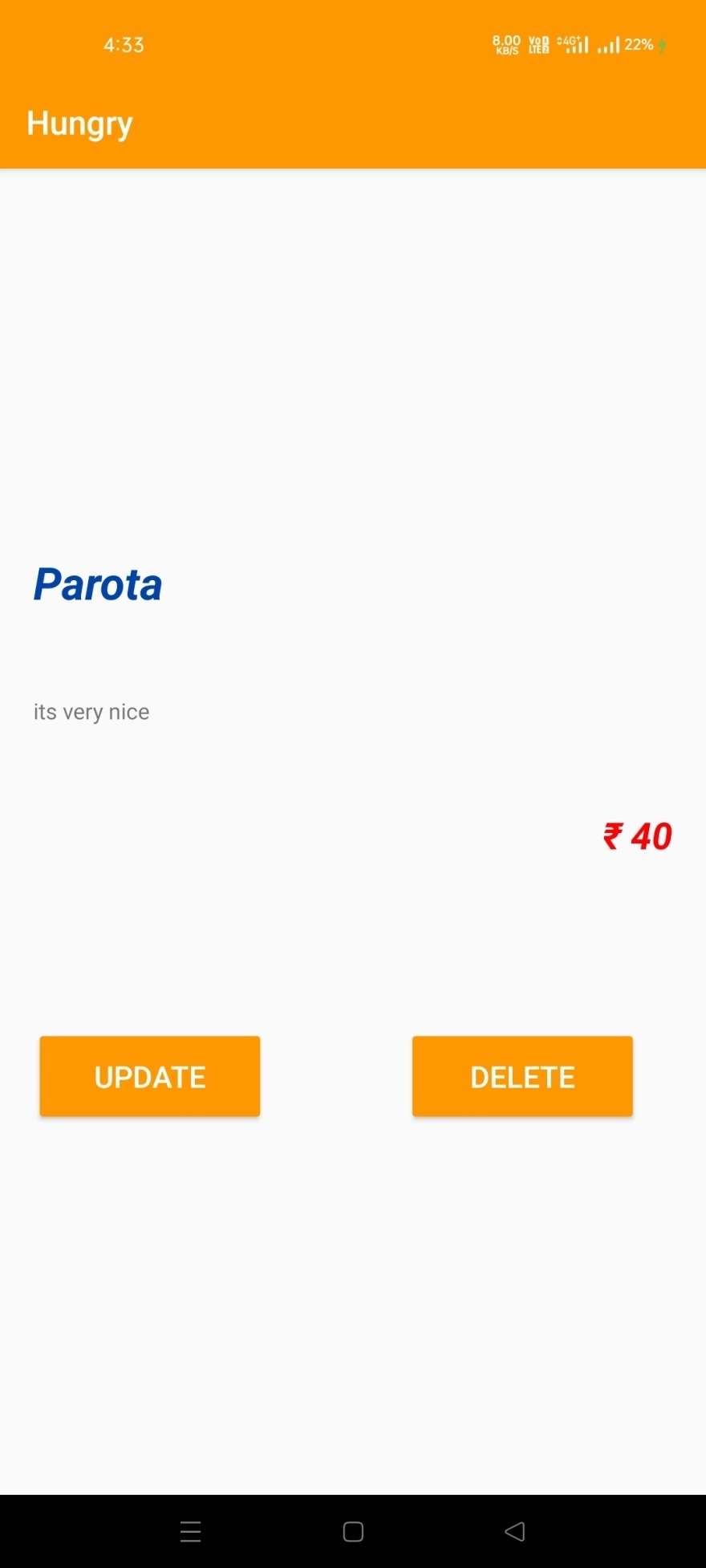

**7.7 Delete option for user**

**CONCLUSION**

This design mainly for early modern life interactive platform system for the complete design and implementation, in the process of system development, mainly used in the dart, flutter class library, main. dart technology, Kotlin, through the development of the system, designed the administrators, different functions such as user roles, and then implements the updating the new recipe’s into the application function. The design of these functions will constitute a complete early interactive platform system, and make the system with strong interactive.

## FUTURE ENHANCEMENT

The world is becoming paperless, in all the fields already using digital applications and android applications. So considering all the requirements of the users in future this can be enhanced by adding some more features like, transportation facility, health management and can also create a responsive website. The project has a very vast scope in future.

Project can be updated in near future as and when requirement for the same arises, as it is very flexible in terms of expansion. With the proposed software of database Space Manager ready and fully functional the client is now able to manage and hence run the entire work in a much better, accurate and error free manner.

# REFERENCES

**Websites:**

1. <https://www.java.com/en/>
2. <https://developer.android.com/studio>
3. https://en.wikipedia.org/wiki/Android_Studio
4. <https://en.wikipedia.org/wiki/Firebase>
5. <https://www.crunchbase.com/organization/firebase>
6. <https://firebase.google.com/products-build>
7. https://flutter.dev/docs/get-started/install
8. https://www.tutorialspoint.com/flutter/index.html